

**Software Requirements**

**Specification**

**for**

**Autonomous Garden Monitoring**

**Version 1.0 approved**

**Prepared by Charles Biffin,**

**Hyungmin Jeon,**

**Tedros Tsegay,**

**Ben Van Cise**

**AGM Inc.**

**20 October 2022**

**Table of Contents**

1. ***Introduction 3***
   1. **Problem statement 3**
   2. **Summary 3**
   3. **Product Scope 3**
      1. In scope **3**
      2. Out of scope **3**
   4. **References 3**
2. ***Overall Description 3***
   1. **Compete analysis 3**
   2. **User Classes and Customer Profile 3**
   3. **Design and Implementation Constraints 4**
   4. **Assumptions and Dependencies 4**
3. ***Specific Requirements 4***
   1. **User Interfaces 4**
   2. **Functional Requirements 4**
   3. **Logical Database Requirements (Remove and keep only in Design) 4**
   4. **Performance and Software Quality Requirements 5**
4. ***Breakdown of work/ Project timeline plan 5***

**Revision History**

| **Name** | **Date** | **Reason For Changes** | **Version** |
| --- | --- | --- | --- |
|  |  |  |  |
|  |  |  |  |

# Introduction

## Problem statement

Agriculture has been the backbone of many parts of the planet, and the critical goal has always been to elevate production so that everybody can access enough food. Many techniques are used in agriculture production to ensure production is improved. In this task, we will discuss using DJI Tello drones to monitor the garden and ensure everything works well. The drone has a camera that can capture clear pictures and stream video. This is what the farmer can use to pinpoint the affected part of the farm, whether by pests or diseases so that it can be controlled. When a farmer wants to inspect how their farm is doing, it is always more effective for them to fly this drone instead of walking around and inspecting the whole farm. The drone will be able to monitor and capture a very clear video of the whole farm in a short period. The farmer will be able to provide the cure quickly. The drone leads to improved crop yield because when it provides information on the affected area, the farmer will visit and give the necessary treatment. This will make the plant's health and productivity better. Using a drone can also help farmers see the effects of climate change and understand how they will respond. Unlike other drones, the DJI Tello drone is small and, therefore, easy to handle, and it can report to the farmer in a short time. Also, the drone is easy for the farmer to learn compared to the other drones. This is because it will be easy for the farmer to understand any report produced by the drone.

## Summary

Our product is needed so that farmers can mitigate crop loss and so that every avid gardener can have a green thumb. Up to 14.1%(or $220 Billion USD) of global foods are lost annually due to plant disease(<https://www.cphdforum.org/index.php/2022/05/26/plant-disease-crop-loss/>). Currently, the main mode of disease detection is laboratory testing, but by the time the testing finishes it could be too late. With our drones, we want to have continuous diagnosing via pictures and machine learning. We know we can improve our customers' lives by mitigating loss of life(Plant Lives).

## Product Scope (in progress -Ben)

### In scope

The Scope of Autonomous Garden Monitoring (AGM) is to create a web application that will integrate with the DJI Tello. The AGM system will allow the Tello to operate safely within the domain of indoor gardening and greenhouse farming. A successful routine of the AGM system involves the following steps:

1. capture images of the desired plants
2. deliver this data to our machine learning model
3. run the ML model on the uploaded images
4. update the user’s garden data.
5. make analysis available to the web application
6. alert user of routine completion

The implementation of the AGM web app will offer insight to the user about their garden’s aggregate health, as well as individualized plant health. Upon signing into a verified account, all of the relevant data will be presented on the user’s dashboard. The AGM web app recommends actions that the user can take to prevent any ongoing plant disease. Alerts will tell the user when a routine has successfully completed, or if the routine failed.

When a routine finishes, the user can view the analysis on the web application dashboard.

The AGM drone will provide:

* *Autonomous flight*
* *The ability to locate and image the plants of indoor gardens*
* *Suitable images to send to our application for assessing plant health*
* *Collision avoidance*

### Out of scope

Given the hardware limitations of the DJI Tello, the implementation of the AGM system offers no extraneous solutions for safely operating in environments *without* well regulated climatic conditions. It is for this reason that development of the AGM system for use with outdoor gardens and crops are out of scope for the implementation.

## References

*<List any other documents or Web addresses to which this SRS refers. These may include user interface style guides, contracts, standards, system requirements specifications, use case documents, or a vision and scope document. Provide enough information so that the reader could access a copy of each reference, including title, author, version number, date, and source or location.>*

# Overall Description

## Compete analysis

## *SWOT analysis :* [*Plantix*](https://play.google.com/store/apps/details?id=com.peat.GartenBank&hl=en_US&gl=US)

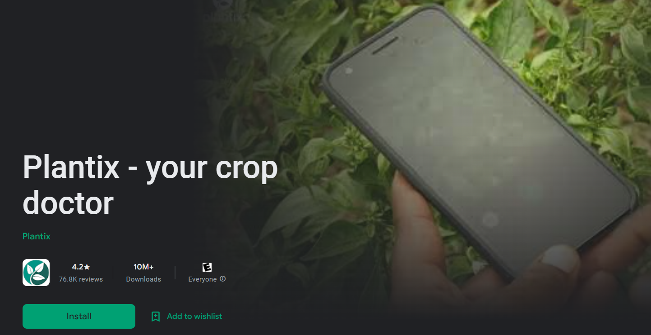

| ***STRENGTHS*** | ***WEAKNESSES*** |
| --- | --- |
| *● Provide instant detection result on the app screen*  *● Provide cultivation tips*  *● Provide social community with 500+ agriculture experts*  *● Fertilizer calculator crop and plot size*  *● Free* | *● Can be used on mobile device only*  *● Pictures can be taken only manually*  *● Need more accuracy on disease detection* |
| ***OPPORTUNITIES*** | ***THREATS*** |
| *● Chance to get sponsorships from pesticides company by showing their product after disease detection*  *● Chance to grow business with social community* | *● Advanced automated garden monitoring software/hardware that doesn’t need manual detection*  *● Not suitable for gardens that have large capacity* |

## User Classes and Customer Profile

We will have two client bases; Gardeners, who just want help keeping track of their plant's health, and Farmers who want to mitigate the loss of life. For our basic gardeners, we will focus on maintaining crops and giving suggestions on how to improve plant quality of life. Gardeners will most likely only need one drone that alerts the user when issues are found. Farmers on the other hand will use x amount of drones to maintain constant surveillance of plants to ensure the minimum amount of disease spreading(x will vary depending on the size of land they wish to cover). Each drone will have its own sector(garden) to look after and once its tasks are complete it will go to a charging/data processing room with all the other drones. Most likely it will be a shed near the farmer's residence to ensure an internet connection. but if no internet is accessible, then it can have its own connected network. A privately connected network would be great for security purposes and can be a feature added on through payment or can be in a subscription tier. Different climate regions might also need different tier levels or more robust hardware such as stronger drones to ensure rain and wind doesn't affect their performance. To ensure that everyone is able to use our product we will have a basic and advanced version of our app/website. The basic version would be for your typical gardener who just wants alerts when issues are detected in their garden. The Advanced version would be for farmers that want to dive into the nitty gritty of plant health and take advantage of technology. The most important version will be advanced since our main clientele(farmers) will want to know all they can about their plants because it is their livelihood.

## Design and Implementation Constraints

* Hardware limitations are the primary limitation of the DJI Tello drone. A hardware limitation constraint is related to drone development and maintenance. This is because for the drone to work effectively, it must be in working condition. This includes a high-quality camera that can detect the change of color in leaves or any pest attacking the crops. At some points, these machines break down, and they need parts and development;
* The drone is constrained by its complex software program. It is made up of complex software, and they always require a specialist who knows them very well. This is because most software developers are used to the old types of drones, which becomes challenging for them to handle when they come across DJI Tello drones. It can take a lot of time and effort to study which parts the drone wants so that they can be developed.
* The drone is constrained by high memory space requirements. Again, the DJI Tello drone requires a lot of memory space to the extent that it can require a petabyte of space. This is so it can be able to store a lot of data. Getting these types of memory is always very difficult, and when you get them, they are expensive.

## Assumptions and Dependencies (in progress -Ben)

The following are main assumptions:

* Users will be using the system for indoor gardening only
* Adequate lighting will be provided by the user in order for the drone to safely navigate the garden
* Each team member will have access to and be responsible for their own drone while testing.
* Opencv will be able to detect all desired plants

Autonomous Garden Monitoring assumes no responsibility for damaged property

# Specific Requirements

## User Interfaces

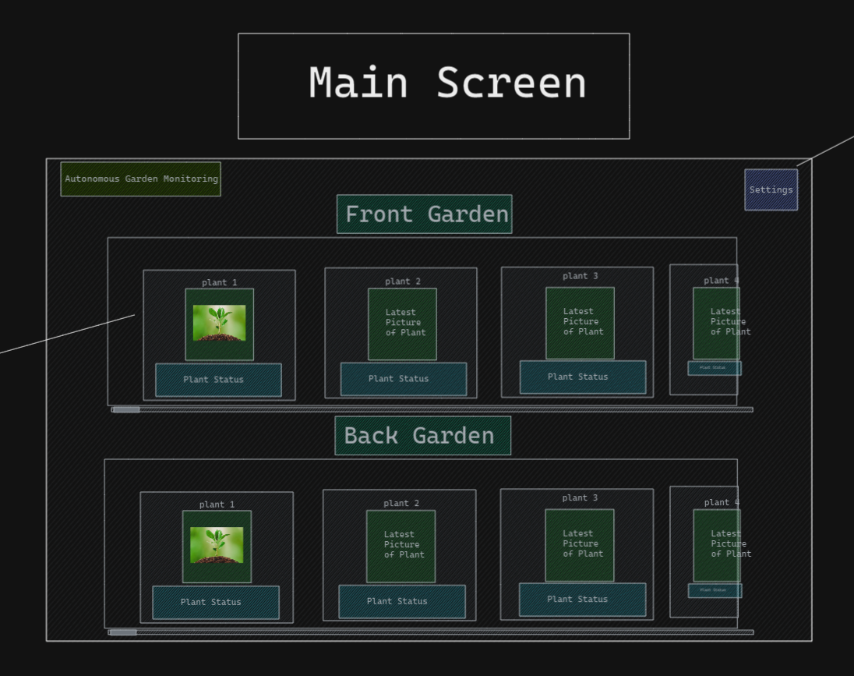

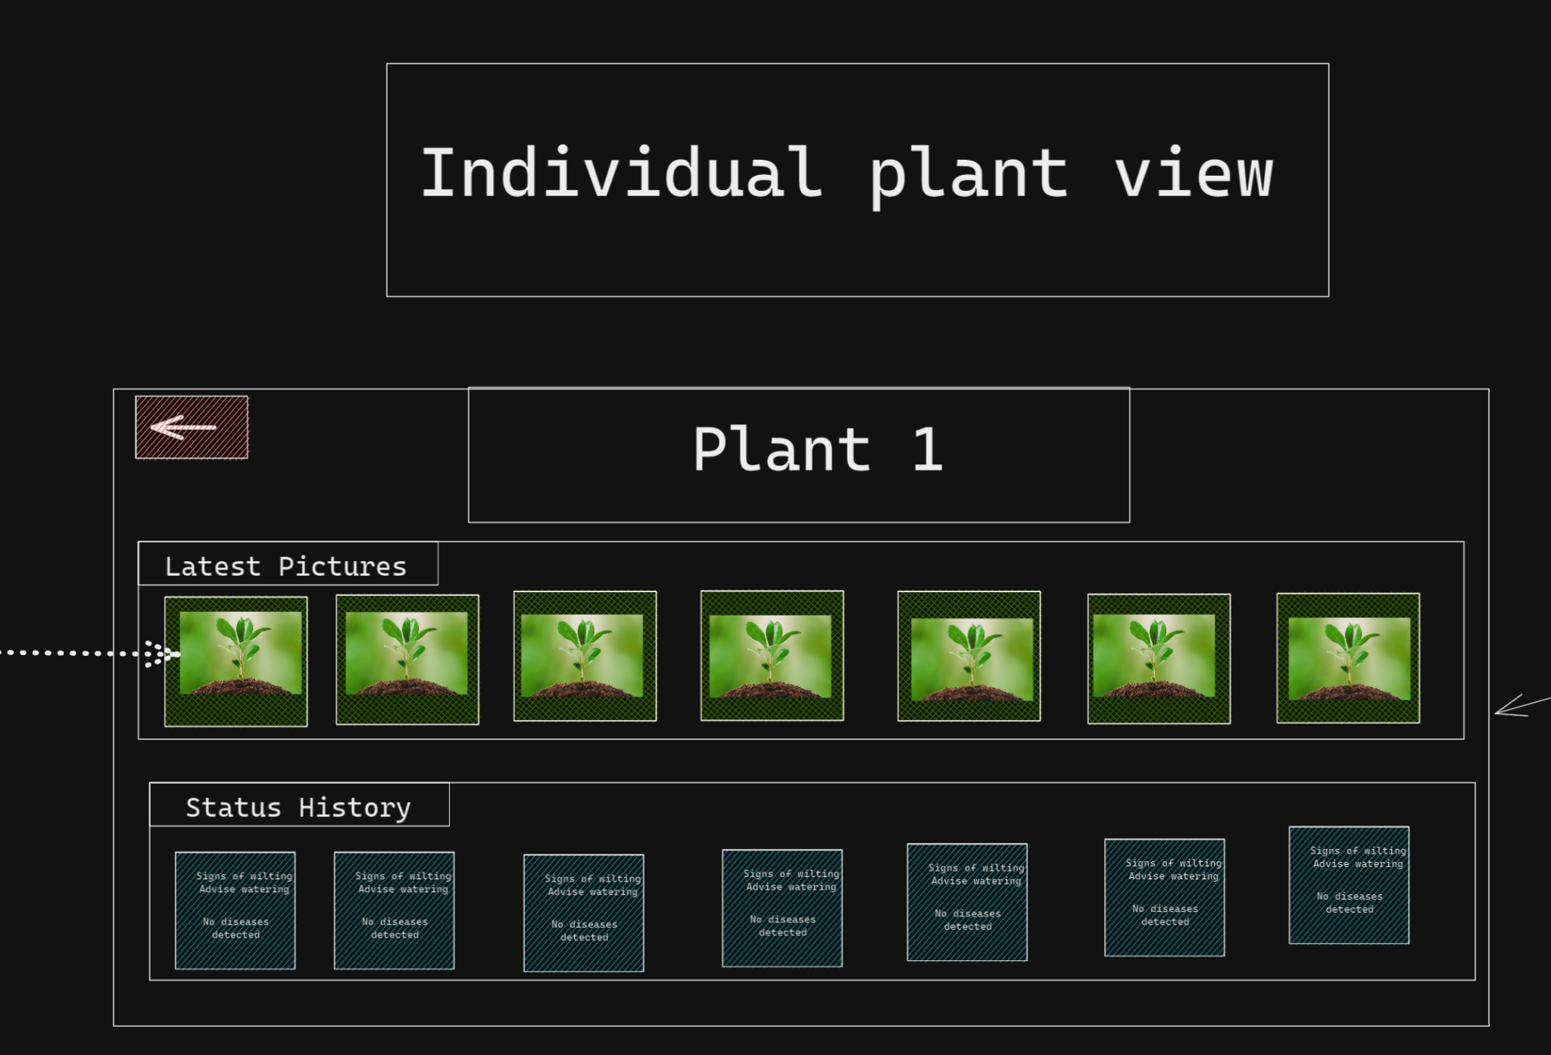

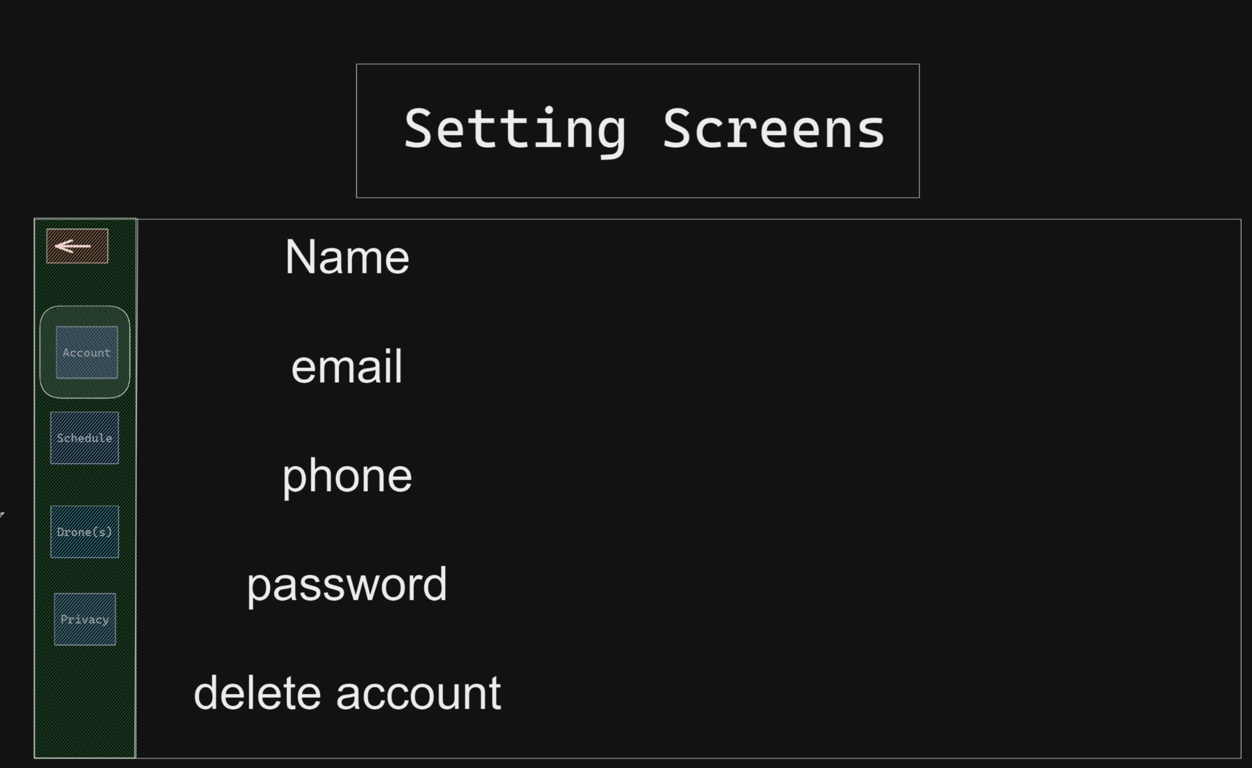

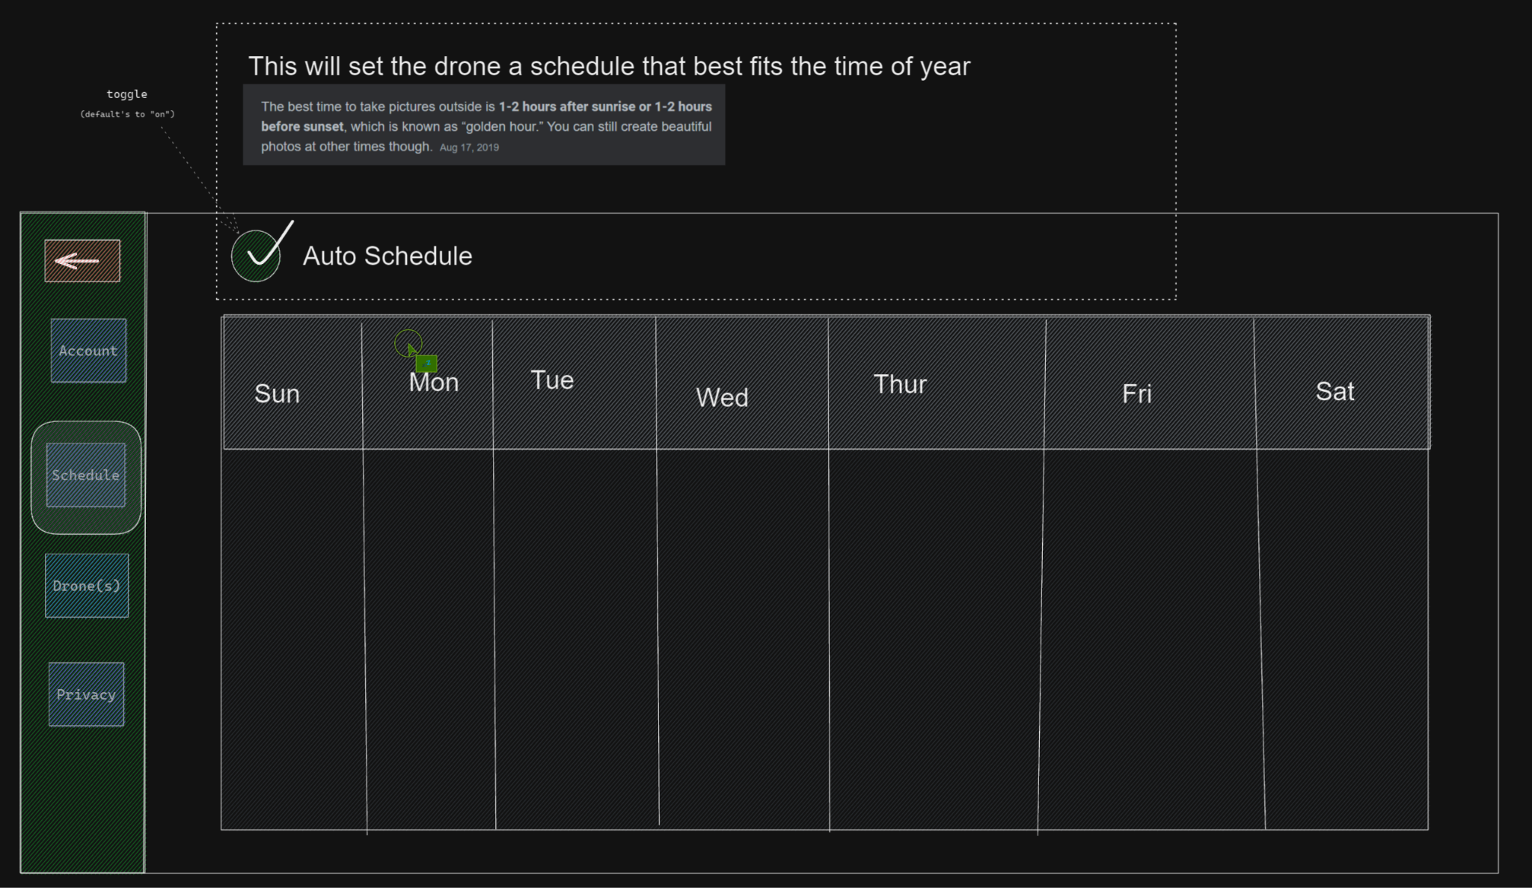

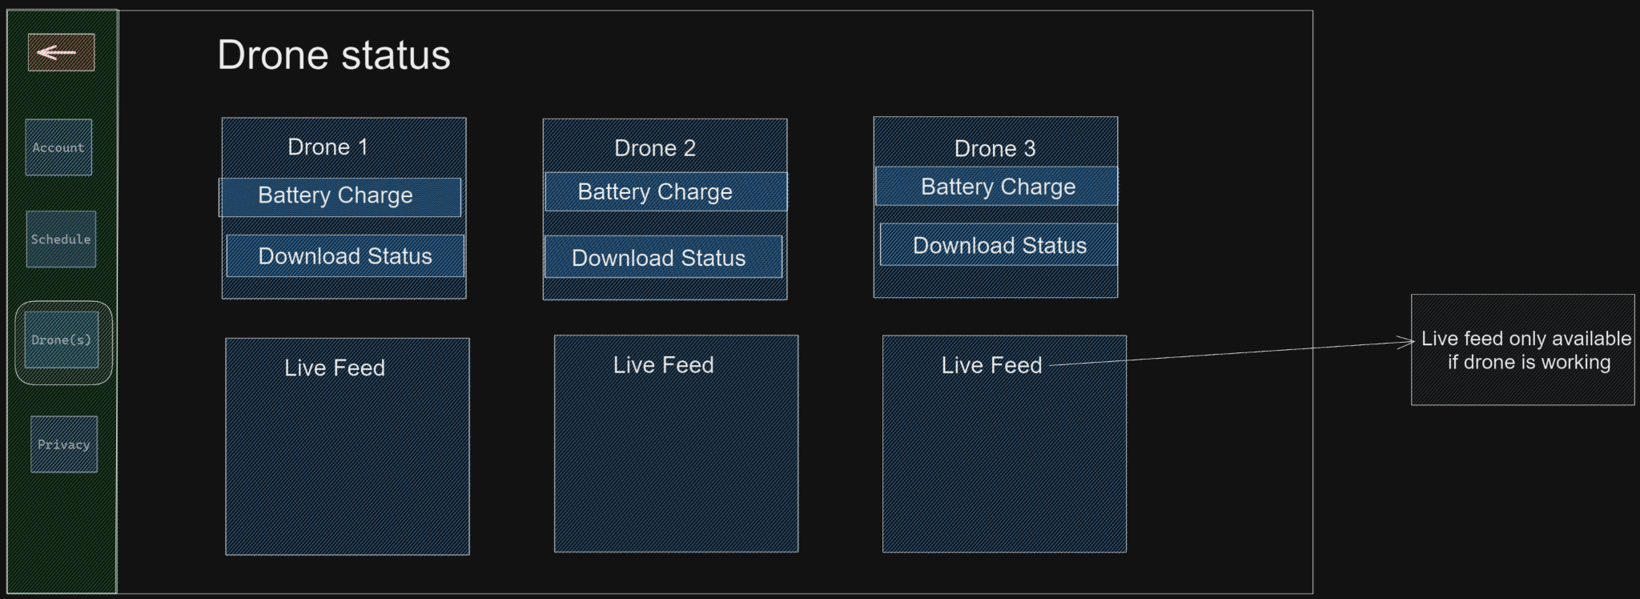

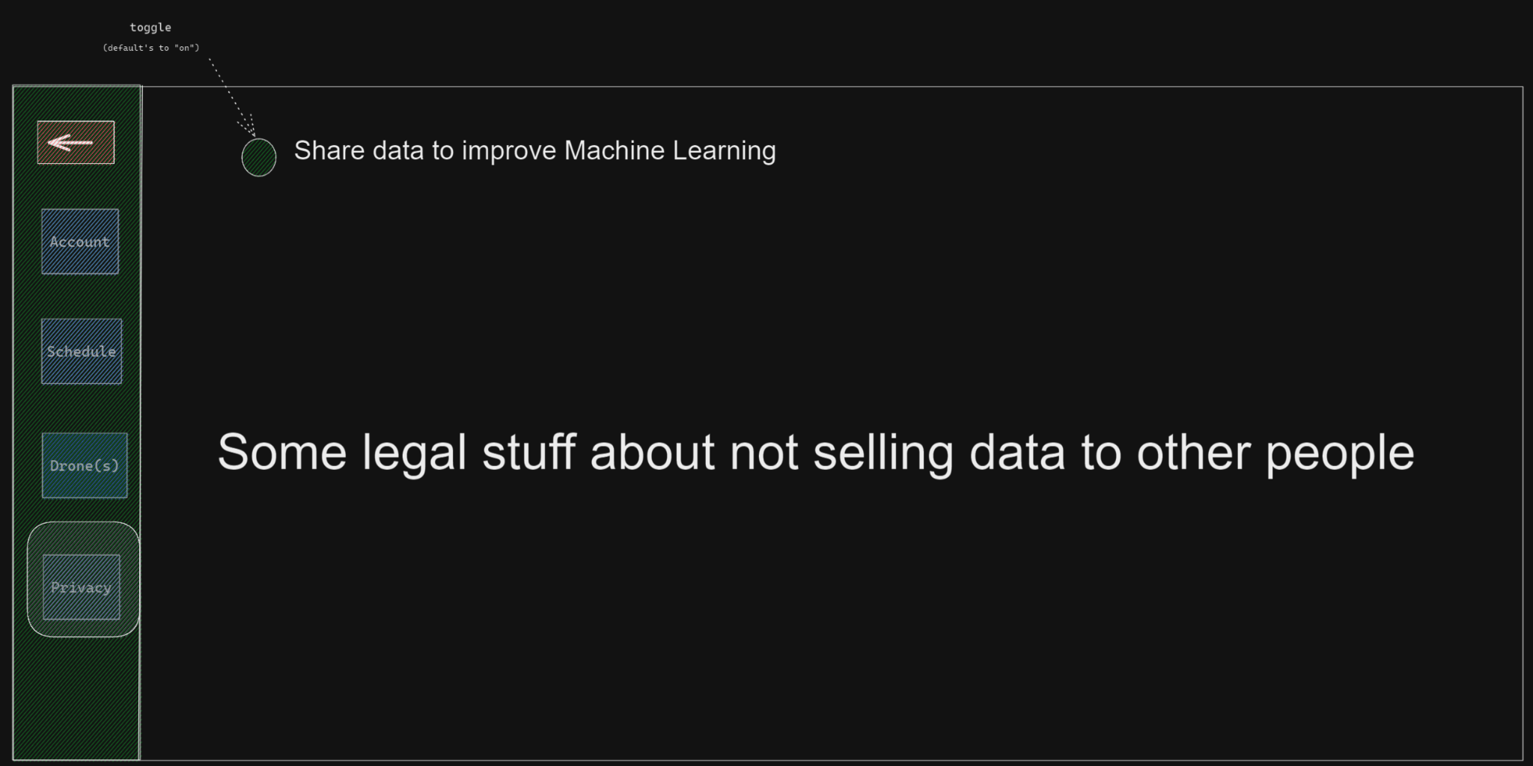

## Functional Requirements

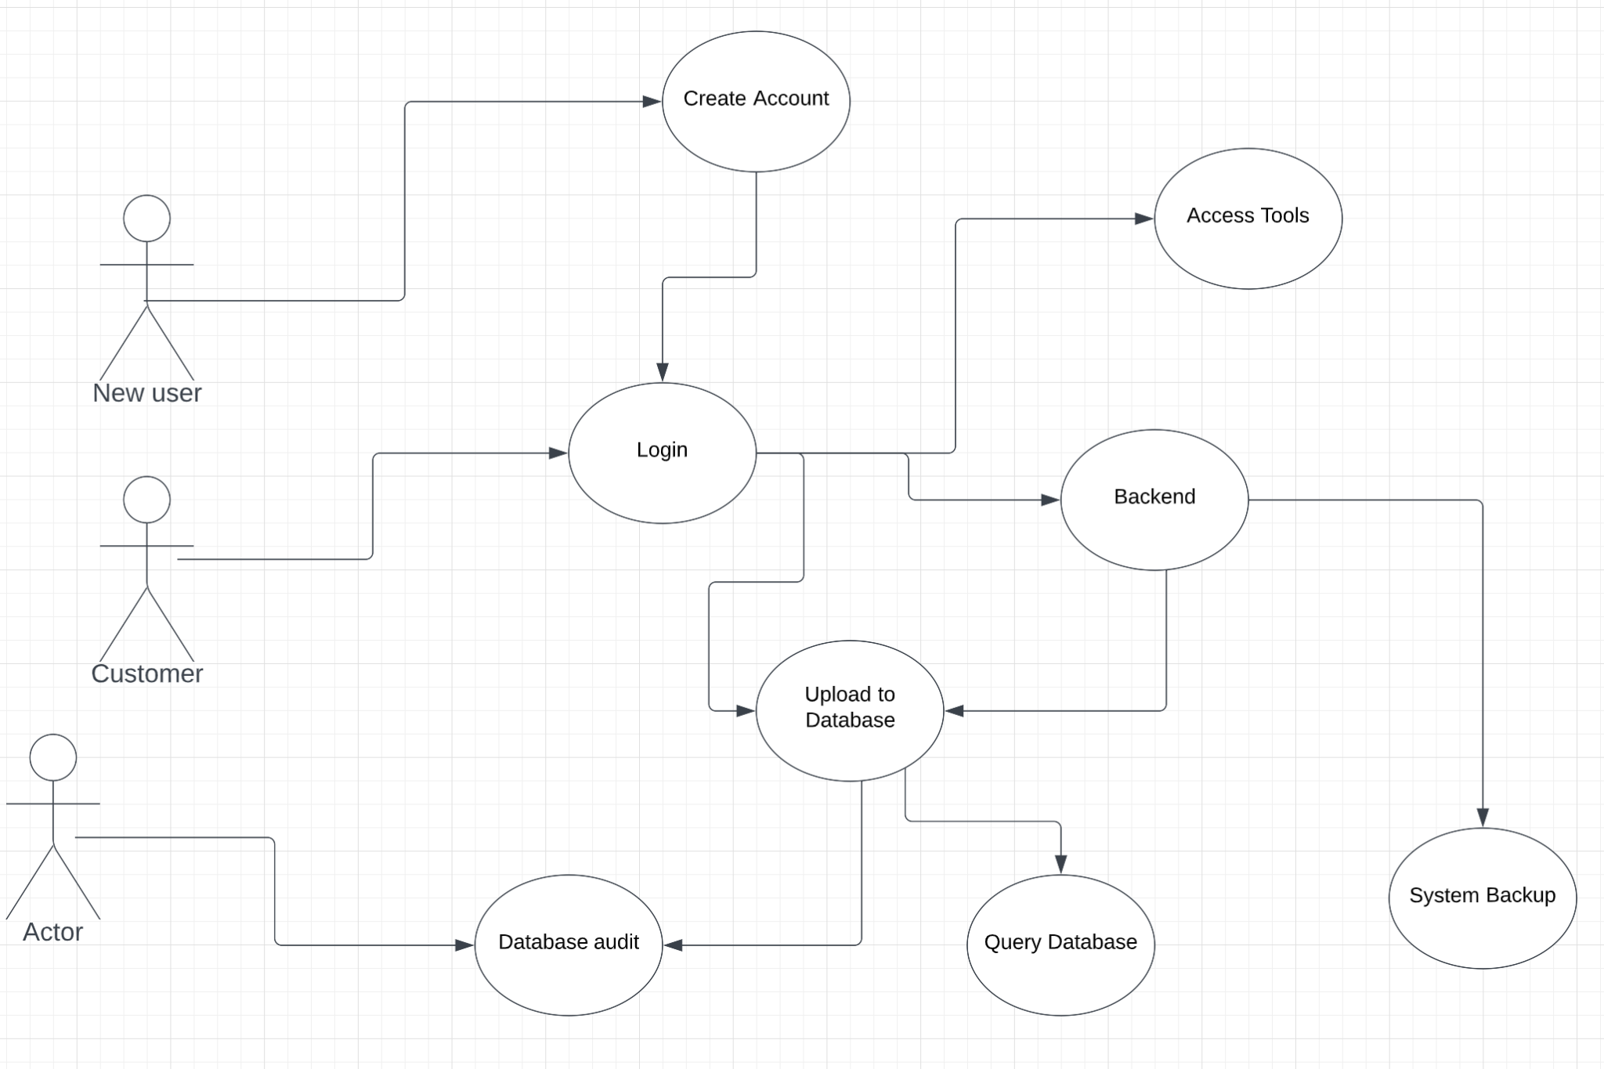

* A new user should be able to create an account using their full name and email address and access the web.
* User should be able to access data after logging in to the web
* Users can access a map which the drone should fly
* User should be able full control the drone using the web
* The system must collect data and provide full access to the user
* The system should provide a correct result of the data collected
* The database should be backed up daily for “recovery options.” In case the portal crashes
* The system should adequately interact with the product.

* 1. **Logical Database Requirements**

Garden {garden_id, name, address_line1, address_line2, city, region, postal_code, country_id}

Gardener {gardener_id, garden_id, first_name, last_name, password, address_line1, address_line2, city, region, postal_code, country_id, email, phone_number}

Drone data {drone_id, garden_id, date, pad_id, pad_x_coordinate, pad_y_coordinate, pad_z_coordinate, vgx, vgy, vgz, pitch, roll, yaw, lowest_temp, highest_temp, tof, h, bat, baro, motor_time, agx, agy, agz, image, video, model, made_year}

Pad {pad_id, garden_id, drone_id, pad_x_coordinate, pad_y_coordinate, pad_z_coordinate, model, made_year}

WIFI {WIFI id, garden_id, ssid, pass}

Plant {plant_id, garden_id, drone_id, date, plant_image, pad_id, pad_x_coordinate, pad_y_coordinate, pad_z_coordinate, tof, h, lowest_temp, highest_temp, plant_type, disease_detect}

___(underline): PK

garden_id is a FK references Garden (garden_id)

drone_id is a FK references Drone data (drone_id)

#pad_id is not a FK references Garden (pad_id) : X <- there’s a chance drone have pad_id value ‘0’

tof: the time of flight distance in cm

motor_time: the amount of time the motor has been used.

ssid: updated Wi-Fi name

pass: updated Wi-Fi password

plant_type: result of the ML algorithm. ex) “Rose”, “Orchid”

disease_detect: result of the ML algorithm. ex) “Yes” or ”No”

## Performance and Software Quality Requirements (in progress -Ben)

adaptability:

* The AGM computer vision systems detect and avoid obstacles in various kinds of indoor environments
* The AGM ML model works well enough to analyze images given various lighting conditions and angles

availability:

* AWS compute, uptime, and support allows users reliable access to their AGM dashboard
* The DJI Tello is widely available at retail
* DJI Tello parts and accessories are widely available at retail

correctness

* The AGM ML model only looks for plant disease that the model has been adequately trained on
* No analysis is full proof

flexibility

* Users can adjust how much of their garden to monitor.
* Users can control which plants and gardens to analyze

interoperability

maintainability

portability

* The AGM app is a web based application and delivers content to a wide variety of devices
* The DJI Tello is lightweight and small

reliability

reusability

robustness

testability

* Any and all functions are testable

usability

# Breakdown of work/ Project timeline plan

| **User Story** | **Millstone** | **Assigned to** |
| --- | --- | --- |
| P0- REQ-1: A user can sign-up for the web | M1 | Hyungmin |
| P0- REQ-2: A user can check plant data after logging in to the web | M2 | Charles |
| P0- REQ-3: A user can access to a garden map | M3 | Ben |
| P0- REQ-4: A user can control the drone on the website | M4 | Tedo |

| P0- REQ-5: A user have full access to drone and plant data | M5 | Hyungmin, Charles |
| --- | --- | --- |
| P0- REQ-6: The Database back up everyday to provide “recovery options.” | M6 | Ben, Tedo |
| . |  |  |